**DAILY ONLINE ACTIVITIES SUMMARY**

|  |  |  |  |  |  |  |  |
| --- | --- | --- | --- | --- | --- | --- | --- |
| **Date:** | **22/06/2020** | | | | **Name:** | **Churashma** | |
| **Sem & Sec** | **4th SEM 'A' Section** | | | | **USN:** | **4AL18CS019** | |
| **Online Test Summary** | | | | | | | |
| **Subject** | | **No test** | | | | | |
| **Max. Marks** | | **-** | | **Score** | | **-** | |
| **Certification Course Summary** | | | | | | | |
| **Course** | **Introduction to R** | | | | | | |
| **Certificate Provider** | | | **greatlearning academy** | **Duration** | | | **3.5 hours** |
| **Coding Challenges** | | | | | | | |
| **Problem statement 1: Write a Java Program for Modular Exponentiation.** | | | | | | | |
| **Status: completed** | | | | | | | |
| **Uploaded the report in Github** | | | | **yes** | | | |
| **If yes Repository name** | | | | **https://github.com/Churashma/Lockdown-coding** | | | |
| **Uploaded the report in slack** | | | | **yes** | | | |

ONLINE TEST DETAILS: No test.

CERTIFICATION COURSE DETAILS: Today I studied about sorting and merging and also I studied about data summaries .A mechanism provided by R programing through which elements of a vector can be arranged in a particular order, usually facilitated by but not just limited to the order() function that assists in sorting the elements either in ascending or descending order, as required, with normal use of order() function sorting the result in ascending order(), otherwise sorting the result in descending order, is known as sorting in R.A very useful multipurpose function in R is summary(X), where X can be one of any number of objects, including datasets, variables, and linear models, just to name a few.

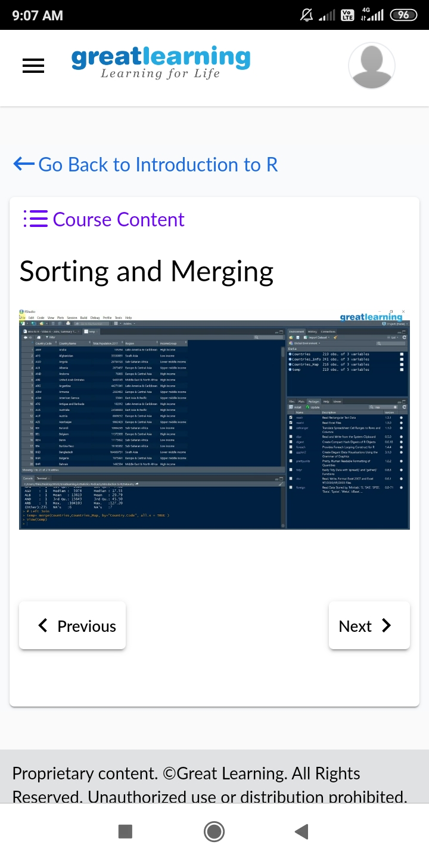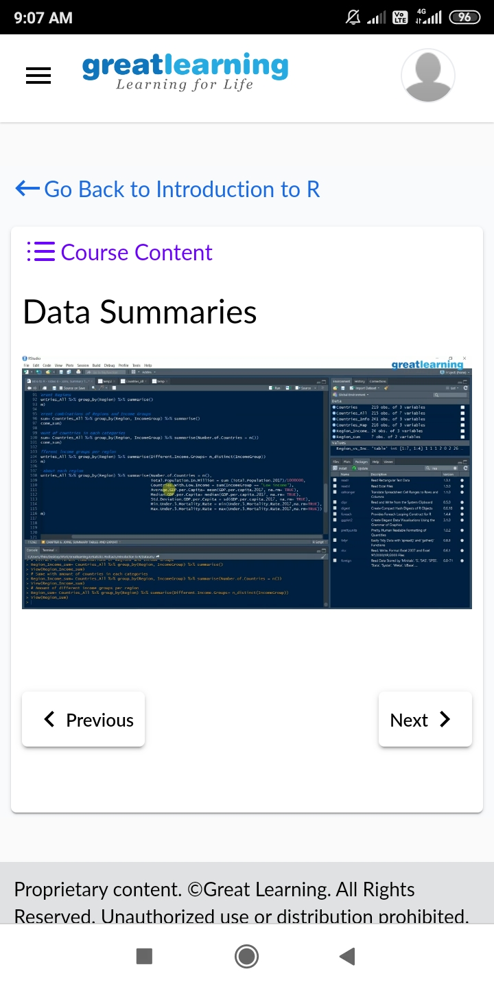

**CODING CHALLENGES DETAILS**:

Problem statement 1: Write a Java Program for Modular Exponentiation.

